**USER GUIDE DOCUMENT**

Table of Contents

Verify whether the application is installed and running perfectly: (CircleAreaV1D0.apk): 3

Verify whether the application developed for the testing is getting installed properly: 4

Verify whether the timer sleep time in the JobThread class is set to 4000(this is important because in robotium there is no option to test an activity which is updating at a very frequent rate): 4

Verify whether the tests are run successfully: 5

Verify whether the tests are executed successfully : 5

## Verify whether the application is installed and running perfectly: (CircleAreaV1D0.apk):

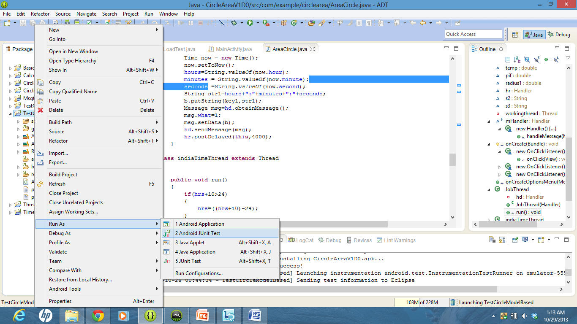

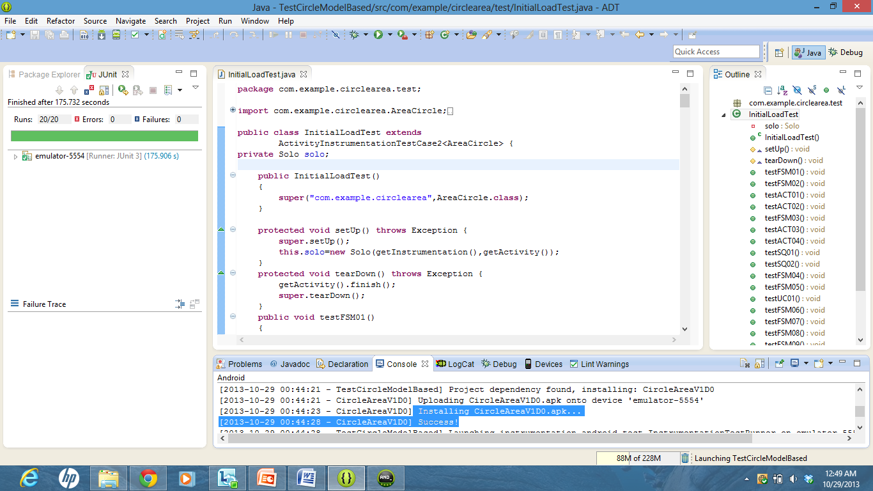

Verify whether the application developed for the testing is getting installed properly:

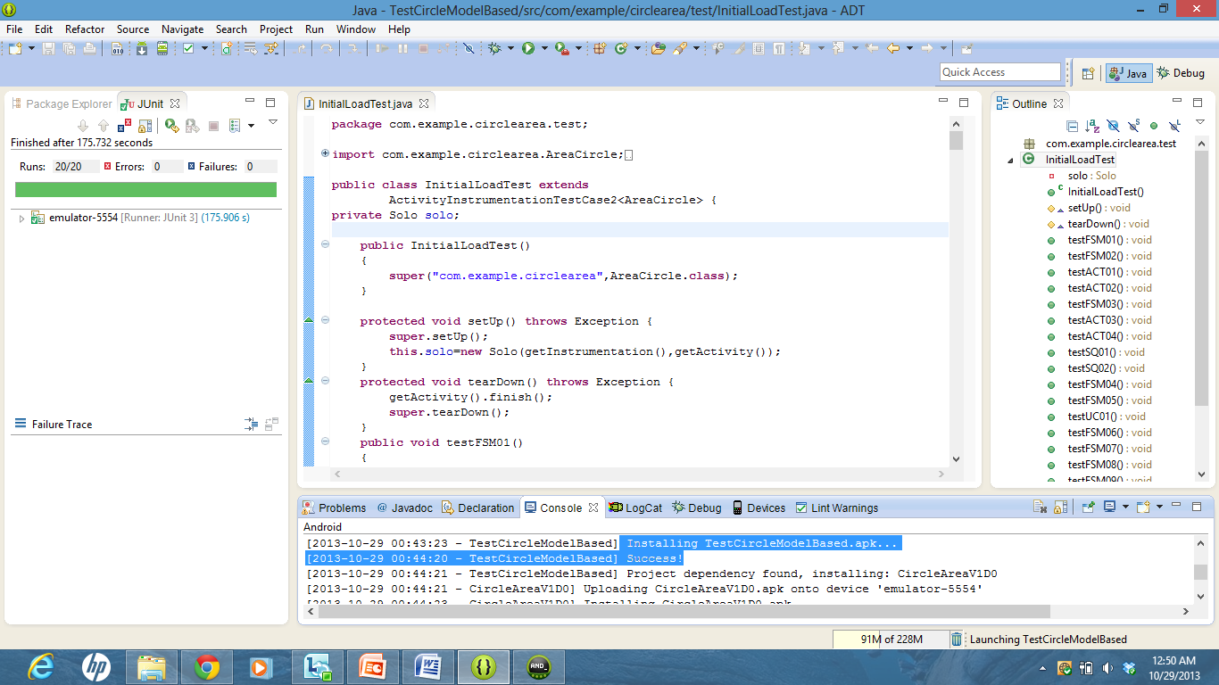

Verify whether the timer sleep time in the JobThread class is set to 4000(this is important because in robotium there is no option to test an activity which is updating at a very frequent rate):

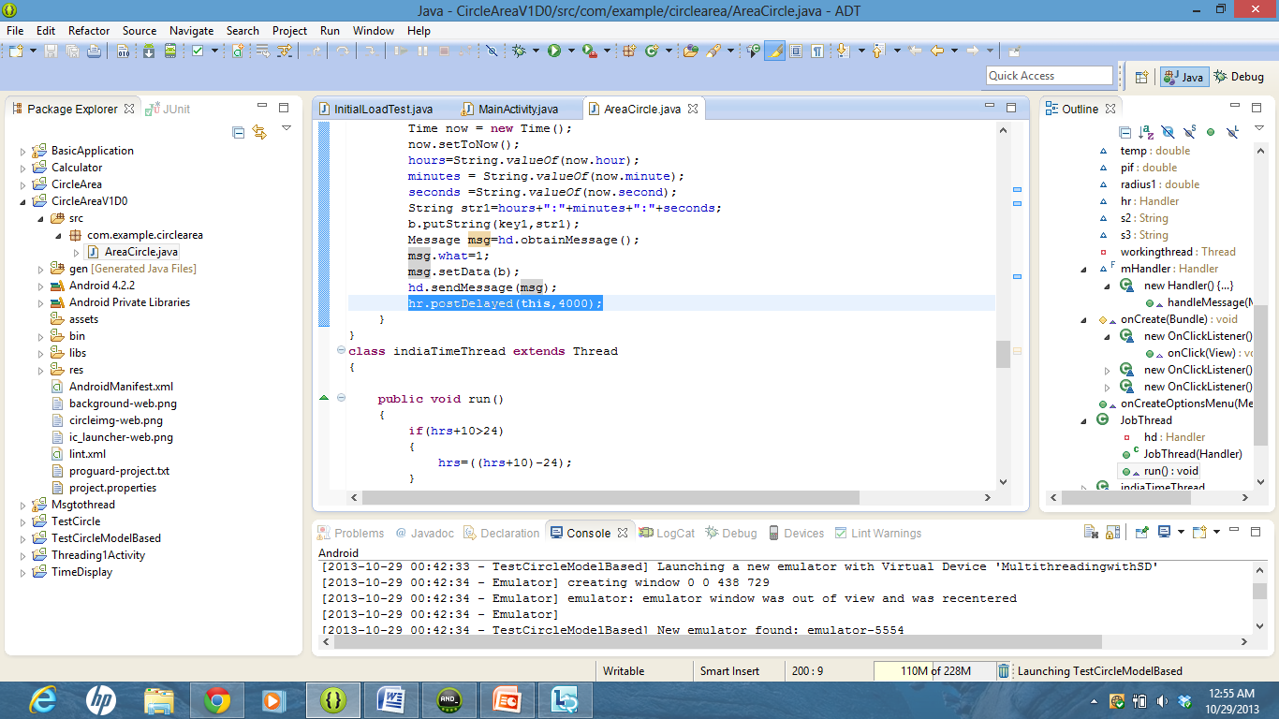

Verify whether the tests are run successfully:

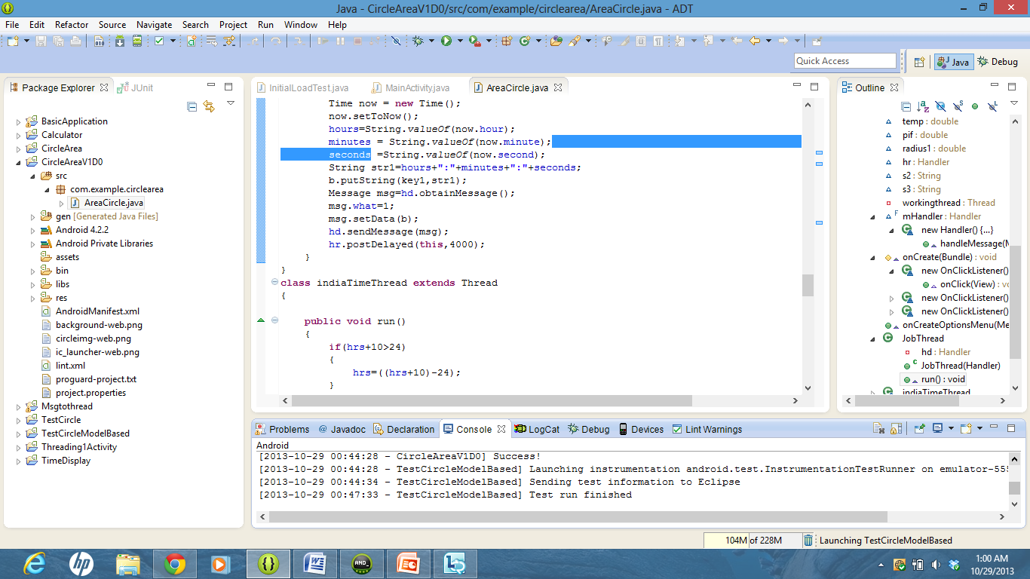

Verify whether the tests are executed successfully :

